Details of the sudden death of Rev Haworth

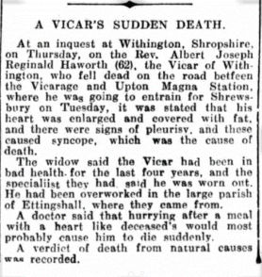
Gloucester Citizen page 3 08 01 1926

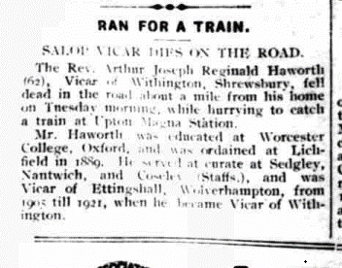

The Kington Times page 5 09 01 1926

