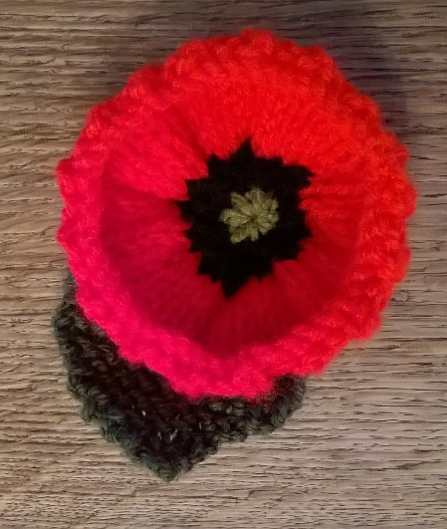
Poppy All in One + Leaf

Measurers approx.. 7cm across

Yarn: Any Red, Black and Green
Needles: One size smaller than recommended
for yarn

I used: 3.75mm needle and double knit yarn

Here’s one I made earlier
Poppy

Cast on 50 stitches

R1 (rs): Knit into back of each st.

R2 (ws): *P2, K1, P2* repeat to end
R3: *K2, P1, K2* repeat to end
Repeat last 2 rows, 2 more times and R2 once (8 rows total).

(Optional change to black)
R9: K2tog across row (25sts)
R10: K2tog across row last stitch K1 (13sts)

(Optional change to green)
R11: K2tog across row last stich K1 (7sts)

Cut tail and thread through 7sts and pull tight sew up seam in red. Sew in yarn ends. Weave in black end in and out of stitches around circle to pad out a bit. Add button if need be.

Leaf

Cast on 8 stitches
R1: K
R2: K f&b 1stst, k to last st, Kf&b (10sts)
R3: K
R4: As R2 (12sts)
R5 to R14: K
R15: K2tog, K to last 2 sts, K2tog (10sts)
R16: K
R17: As R15 (8sts)
R18: K
R19: As R15 (6sts)
R20: K
R21: K2tog, K2, K2tog (4sts)
R22: K
R23: K2tog, twice (2sts)
Cast off.

Sew in cast off yarn to form tip of leaf. Use cast on tail to sew to back of poppy.

