

YOU WILL NEED
- DROPS Cotton Viscose (54% cotton, 46% viscose, 50g/110m) 1 ball of each:
Dark Red (07)
Black (15) or similar DK weight yarn
- A 3mm (US C/2 or D/3) hook
- Stitch marker
- For yarn stockists, contact Wool Warehouse 01926 882818 www.woolwarehouse.co.uk
MEASUREMENTS
- 5cm (2in) in diameter
ABBREVIATIONS
- Double Treble (Dtr) Yrh twice, insert hook in stitch, yrh and pull up loop, (yrh and draw through 2 loops) 3 times
- Triple Treble (Ttr) Yrh three times, insert hook in stitch, yrh and pull up loop, (yrh and draw through 2 loops) 4 times
BROOCH
With Black, make a magic loop.
Rnd 1 (RS) Ch1 (does not count as st throughout), 8dc into loop, ss to first dc. [8 sts]
Rnd 2 Ch1, 2dc in each st around, ss to first dc. Fasten off. [16 sts]
Rnd 3 Join Dark Red into any st, ch1, working in back loop only of next 5 sts of prev rnd: dc in next st, htr in next st, tr in next st, 2dtr in next st, 2ttr in next st. Now working in both loops for next 4 sts: (2ttr in next st) 4 times. Working in back loop only for rem sts of this rnd: 2ttr in next st, placing a marker in the base of this st, 2dtr in next st, tr in next st, htr in next st, dc in next st. Fasten off, leaving rem sts unworked. [22 sts]
Rnd 4 Rejoin Dark Red in rem front loop of marked st. Ch1, working in rem front loops of next 5 sts, in front of petal already worked: dc in marked st, htr in next st, tr in next st, 2dtr in next st, 2ttr in next st. Working in both loops of next 2 sts: (2ttr in next st) twice. Working in rem front loops for rest of rnd: 2ttr in next st, 2dtr in next st, tr in next st, htr in next st, dc in next st. Fasten off and weave in ends.
YOU WILL NEED
- DROPS Cotton Viscose (54% cotton, 46% viscose, 50g/110m) 1 ball of each:
Dark Red (07)
Black (15) or similar DK weight yarn
- A 3mm (US C/2 or D/3) hook
- Stitch marker
- For yarn stockists, contact Wool Warehouse 01926 882818 www.woolwarehouse.co.uk

MEASUREMENTS
- 5cm (2in) in diameter
ABBREVIATIONS
- Double Treble (Dtr) Yrh twice, insert hook in stitch, yrh and pull up loop, (yrh and draw through 2 loops) 3 times
- Triple Treble (Ttr) Yrh three times, insert hook in stitch, yrh and pull up loop, (yrh and draw through 2 loops) 4 times
BROOCH
With Black, make a magic loop.
Rnd 1 (RS) Ch1 (does not count as st throughout), 8dc into loop, ss to first dc. [8 sts]
Rnd 2 Ch1, 2dc in each st around, ss to first dc. Fasten off. [16 sts]
Rnd 3 Join Dark Red into any st, ch1, working in back loop only of next 5 sts of prev rnd: dc in next st, htr in next st, tr in next st, 2dtr in next st, 2ttr in next st. Now working in both loops for next 4 sts: (2ttr in next st) 4 times. Working in back loop only for rem sts of this rnd: 2ttr in next st, placing a marker in the base of this st, 2dtr in next st, tr in next st, htr in next st, dc in next st. Fasten off, leaving rem sts unworked. [22 sts]
Rnd 4 Rejoin Dark Red in rem front loop of marked st. Ch1, working in rem front loops of next 5 sts, in front of petal already worked: dc in marked st, htr in next st, tr in next st, 2dtr in next st, 2ttr in next st. Working in both loops of next 2 sts: (2ttr in next st) twice. Working in rem front loops for rest of rnd: 2ttr in next st, 2dtr in next st, tr in next st, htr in next st, dc in next st. Fasten off and weave in ends.

How to make a magic loop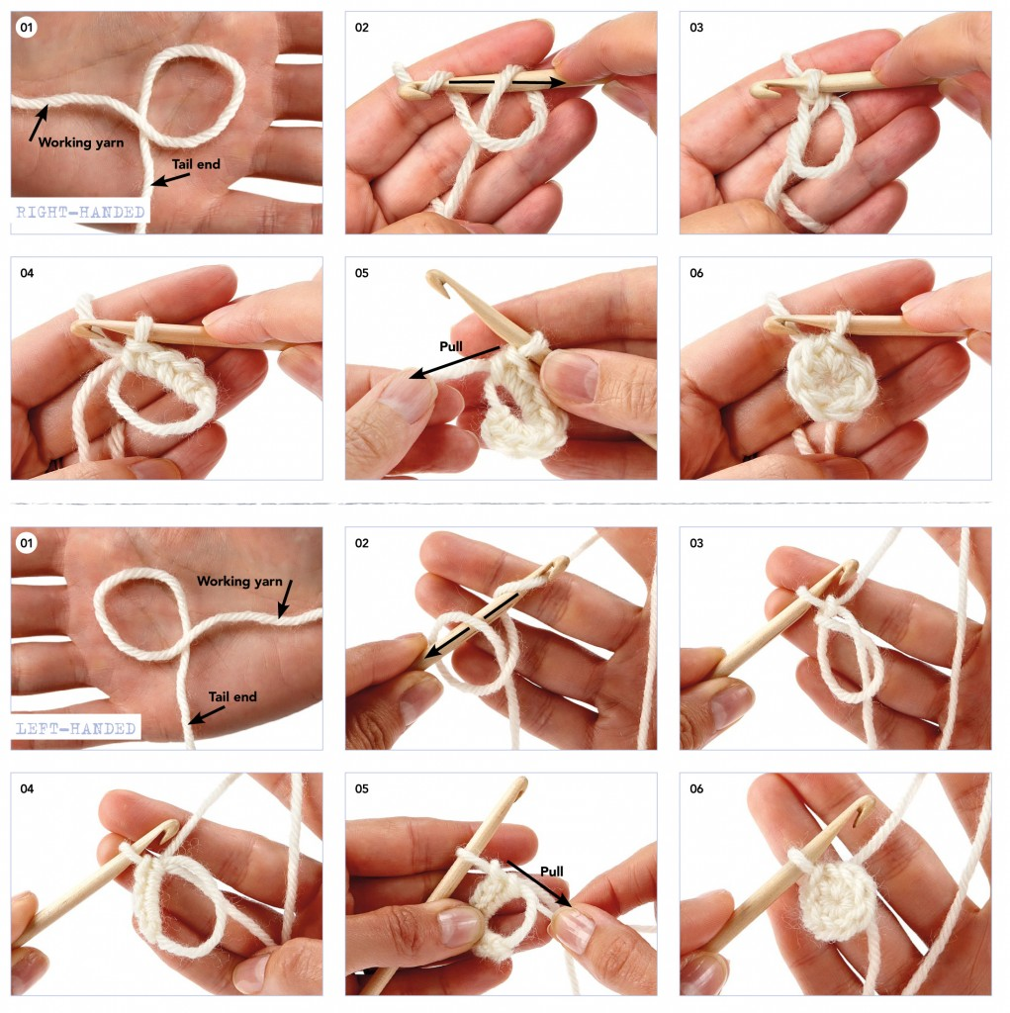
Also known as a Drawstring Ring or Magic Ring, the Magic Loop is popular when working amigurumi. Work as follows:
Step 1 To start a Magic Loop, don’t make a slipknot. Instead, make a loop with the yarn, leaving a tail around 10cm long. Make sure the tail end is on the bottom.
Step 2 Now insert your hook into the loop, from front to back. Wrap the working yarn around the hook anticlockwise and pull the yarn through the Magic Loop.
Step 3 Now make a turning chain, the correct length for the stitches you want to work. In the example above, we’ve worked double crochet stitches, so we’ve made one chain for the turning chain.
Step 4 Now work your stitches into the Magic Loop, making sure all the stitches are worked over both the loop itself and the tail end (so two strands of yarn).
Step 5 Once you’ve worked the number of stitches you need, simply pull the tail end of the yarn to draw up the ring – magic!
Step 6 Close rnd with a slip stitch as usual.

