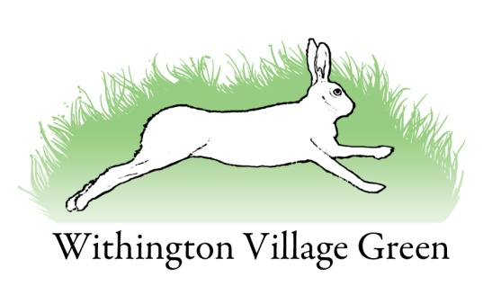

Village Green Committee Meeting
Wednesday 30th August 2017
at 8.00pm in the Hare & Hounds

Agenda

- Present and apologies

- Approval of the Minutes of 7th March 2017.
Approval of the AGM Minutes 11th May 2016

- Vintage Tractor Day.

- Fruit from the Fruit Trees.

- Website Details of Committee Members

- Finance.

- AOB

Next Meeting: Wednesday 25th October 2017

