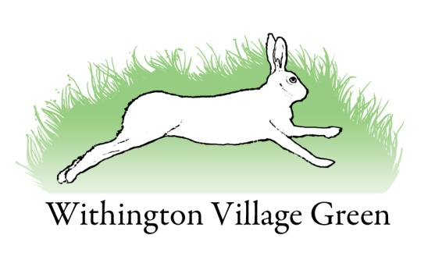

Village Green Committee Minutes
Tuesday 2nd February 2016

Attendees
Chair: Wayne Thomas
Treasurer: Alan Williams
Secretary: Lisa Gray
Phil Heath
Brenda Scutt
Ron Lucas
Member of the public: Lesley Stone

Apologies
Martin Timmis
Vicky Timmis
Tom Taylor
Dave Pye

Minutes
Minutes of the meetings on the 3rd November and 8th December 2015 were accepted as accurate.

Matters arising

Christmas tree
ACTION: Lisa to discuss progress with the acquisition of a new Norwegian Spruce with Bernie Jones. Aiming to plant in March.

Servicing of the mower
The mower is being collected this following weekend. Ron has confirmation that Derek Jones has public liability insurance. He isn’t however VAT registered so they’ll be no VAT to recover. The mower is due back by the end of March. The total cost was estimated at £1250 which was approved by the Parish Council; however that has now increased to nearer £1300 due to increased cost of the components.

Village green path
Quotes have now been received for the cost of completing the tarmacking of the path. The most expensive quote was £55,000, and even the lowest wouldn’t be covered by the £12,000 potential grant from Tesco. It was suggested that we professionally lay the dust we have instead with the funds. ACTION: Wayne to get a quote to professionally relay the dust, and dig out the large stones. ACTION: One further quote to be obtained from Richard Allmark who is yet to quote for tarmacking the path. It was AGREED that Wayne would continue to pursue the grant from Tescos. And that Committee members would lay the dust on a 20m stretch of path as a trial in April. ACTION: Lesley to explore potential options for farms taking the rubble for gateways.

Grants for sports equipment

The LJC meeting was cancelled. ACTION: Martyn Timmis to follow up.

Village pond
It was AGREED that a working party would remove the wild willows in the summer when the ground is harder. Joe Ford has agreed to support with his machinery.

Finance
The balance brought forward from 31st October 2015 was £3,262.18. The income from the Friends of the Green donations was £310.50 leaving a total of £3572.68 in the budget.

Minus expenditure (for lawn mower blades) of £380.38, leaves a total balance as of 2nd Feb 2016 of £3192.30.

