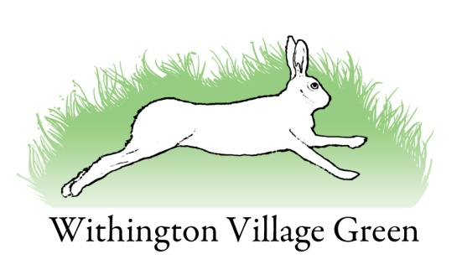

Village Green Committee Minutes
Tuesday 19th July 2016

Attendees
Chair: Wayne Thomas
Secretary: Lisa Gray
Phil Heath
Brenda Scutt
Ron Lucas
Dave Pye
Martin Timmis

Apologies
Treasurer: Alan Williams

Matters arising

Tesco bid
Wayne advised that if we get into the top 3 we will be invited to participate in a competition.

Hedge
The inside of the hedge needs cutting. ACTION: Ron to arrange for Ian to do this.

Village green wet area and willows
ACTION: Phil to discuss with Joe and use his machine to pull out willows. See actions below relating to the path.

Village green path
The path needs weeding and dusting. The weeds have been sprayed.

ACTION: It was agreed that Mark and Dave Buswell would use their machines to burn weeds off, drag all the big stones out, damp down and lay the dust along with working party volunteers. The date for this working party was agreed as Tuesday 26th July at 4pm. Participants to bring equipment including 2 hard brooms, 2 volunteers to sweep, mower, rakes, trailer, gas bottle (Dave Pye). Volunteers agreed as: Phil, Wayne, Dave B, Mark, and Ron. ACTION: Phil to check if Joe is available at the same time to deal with the willows as part of the working party.

AOB
Lisa requested using the green for parking for a few cars for Saturday 6th August. The committee agreed.

